IT/CS 803 Mixed-Initiative Intelligent Systems

Schema-based Approach to Specifying Conversation Policies
Lin, F., Norrie, D.H., Shen, W., and Kremer R. (1999)
Autonomous Agents '99 Workshop on Specifying and Implementing Conversation Policies, Seattle, WA. pp. 71-77

Review by
A. Erkin OLMEZ
GMU, Spring 2004

Purpose of presentation

- Aim: To present a sample paper to discuss the applicability of schema based approaches to analyze and evaluate mixed initiative collaboration interactions.

- Outline:

⇒ Presentation of the paper
Main idea of the paper
Strengths and weaknesses of the approach
Paper's explicit definition of MI reasoning
Paper's approach to six MI issues
How will the paper help my research
What related papers do I plan to read

- Outline:

⇒ Presentation of the paper
Communication challenges
Conversation Policy concept
Colored Petri Nets
Schema Based Conversation Modeling approach

Communication challenges

  - The communication issue: The protocols that facilitate the exchange of knowledge and information between the human and the agent (s), including mixed-initiative dialog and multi-modal interfaces.

  - To facilitate coordination and collaboration, it is vital that agents exchange information about goals, intentions, results and states.

1) Reliable communication challenge:
  - No possible inconsistencies and deadlocks shall occur during communication.

2) Efficient communication challenge:
  - Efficient coordination among agents shall be achieved by minimizing communication and processing overheads.

3) Flexible communication challenge:
  - Ideally, communication models shall be reusable and support applications in multiple domains (tutoring systems, scheduling systems…)

What is a deadlock?

  - Permanent blocking of a set of processes that either compete for system resources or communicate with each other.
  - In a computer system deadlocks arise when members of a group of processes which hold resources are blocked indefinitely from access to resources held by other processes within the group.
  - In communication deadlocks, messages are the resources for which agents/processes wait.

http://www.ni.schule.de/~caeci/inf/deadlock.htm
Conversation Policy concept

  - "Conversations" are sequences of messages involving two or more agents intended to achieve a particular purpose (Smith, 1998). "Conversation Policies" enable agents to coordinate frequently recurring interactions of a routine nature simply and predictably.

  - Basic Conversation Policies (Suite-Bradshaw, 1997)
Inform, Offer, Request, Call for Action.

Sample Conversation Policies from the Suite
"INFORM" (Bradshaw, 1997)
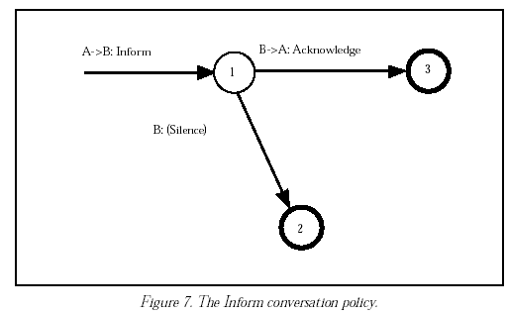
Sample Conversation Policies from the Suite
"OFFER" (Bradshaw, 1997)
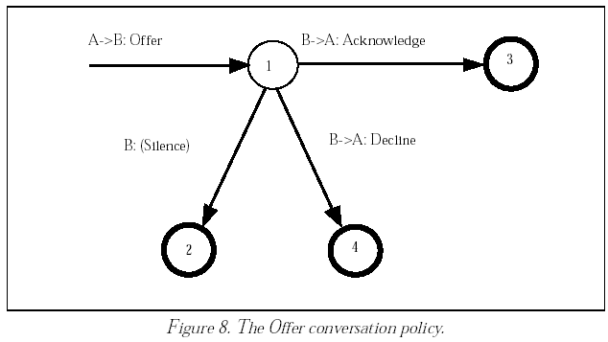
Sample Conversation Policies from the Suite
"REQUEST" (Bradshaw, 1997)
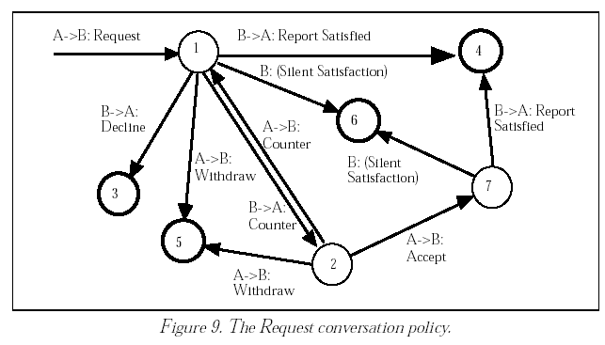
Adding the “QUERY” Conversation Policy to the Suite
(Bradshaw, 1997)
The verb may act as an initial verb and specify the conversation policy for a new conversation
The verb may be used during the course of an existing conversation
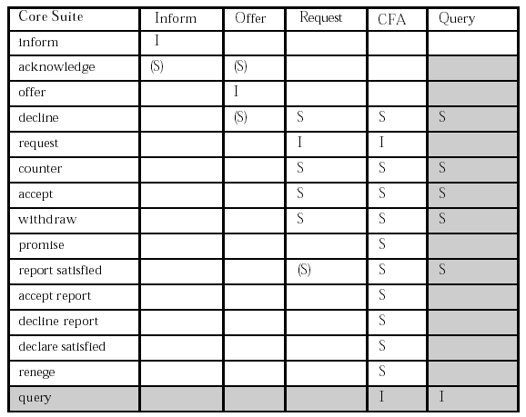
Use of the verb is optional in certain contexts. i.e. acknowledgement in inform messages
Sample Conversation Policies from the Suite
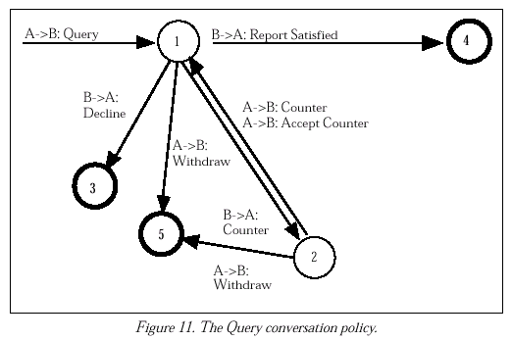
"QUERY" (Bradshaw, 1997)

  - The major difference between the Query and Request conversation policies is that the B:A report satisfied message is not optional, and it must by definition contain some result (i.e., a response to the query) as part of its content.

  - The suite can be extended by combining existing conversation policies with new initial verbs (e.g. retire, advertise, and recommend).

  - The advertise message uses the Offer conversation policy with a more specific verb. The retire message is used by an agent to withdraw its services and uses the Inform conversation policy. The recommend message is used to request help in finding an agent to perform some service. Recommend uses the Query conversation policy.
Quick Summary of the paper

  - Proposes a schema-based specification method for conversation policies.
  - Conversation schemas are modeled through first investigation of interactions among agents to exchange information.
  - This information is specified through a set of "conversation topics".
  - Colored Petri Nets are used as a
    - Specification
    - Verification
tool for conversation schemas at the design stage.
  - Examples in manufacturing systems are used to illustrate the concepts and method proposed.

- Outline:

Presentation of the paper
Communication Challenges
Conversation Policy Concept
⇒ Colored Petri Nets
Schema based Conversation Modeling Approach

Petri Nets

  - Petri Nets are executable "bipartite directed multi-graphs" with four elements:

- Place nodes
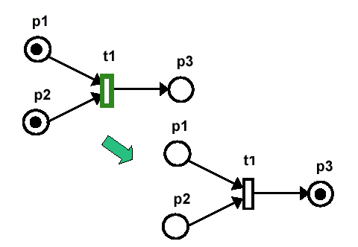
- Transition nodes
- Arcs
- Tokens (markers)
Petri Nets

  - Petri Nets model discrete event dynamical systems:
- They are executable.
- They give a graph theoretic representation of the process communications and control patterns.
- They capture the precedence relations and structural interactions of concurrent and asynchronous events.
- They provide mathematical framework for analysis and validation.
  - Colored Petri Nets are a generalization of Petri Nets
- They allow more precise and detailed models of complex asynchronous processes.
- Tokens are no longer indistinguishable but own some attributes (called colors).
Dynamics of the perfectly elastic collision of two billiard balls (Levis, 2000)
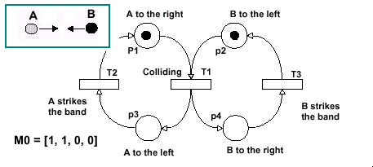
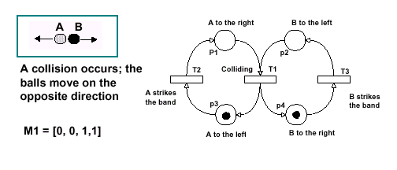
1
2
Observations:

  - This is an autonomous Petri Net: no external synchronization; no time.
  - The Petri Net has four states: M0, M1, M2, M3.
  - The set of reachable markings from M0 is:
    - M0=[1,1,0,0]
    - M1=[0,0,1,1]
    - M2=[1,0,0,1]
    - M3=[0,1,1,0]

  - The Petri Net is bounded; the number of possible tokens in every place is bounded.
  - The Petri Net is safe; the marking of each place is Boolean: 0 or 1.
Observations:

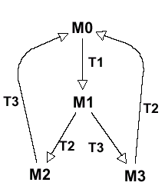
- The Petri Net is live: No transition will become unfirable on a permanent basis; this can be seen by the reachibility tree (or occurrence graph) on the right.
Colored Petri Nets

  - Tokens have attributes; they are "typed" as Colorsets.
  - The types of Colorsets are declared in a Global Declaration Node.
  - Places are assigned Colorsets indicating the type of tokens that can reside in a place.
  - Arcs have arc inscriptions that indicate
- The values of the token attributes in the input places that are necessary to enable a transition.
- Specify the token (s) that will be generated in the output place (s)
  - The execution or firing rules are similar to ordinary Petri Nets
- A transition is enabled when there are tokens in each input place that satisfies the conditions expressed on the input arc inscriptions.
- When the transition is enabled, it can fire, and when it fires, it removes the tokens from the input place that caused the enablement and places tokens in the output place as specified by the output arc inscriptions.
CPN Execution: Example (Levis, 2002)

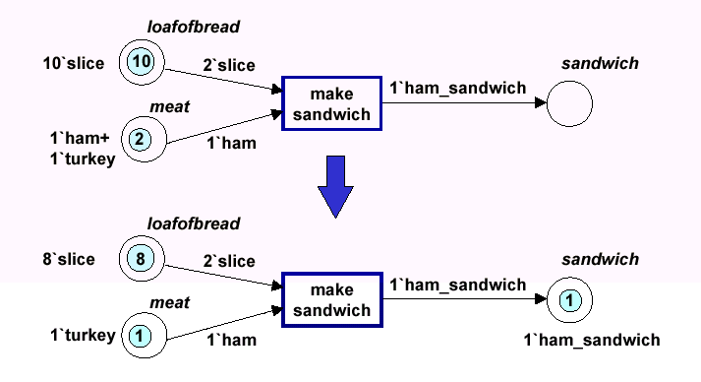
color loafof bread = with slice;
color meat= with ham | turkey;
color sandwich = with ham_sandwich | turkey_sandwich;
Evaluation using Colored Petri Nets

An executable model can be used in three forms of evaluation.
  - Logical
  - Behavioral
  - Performance

The first step is to validate the logic of the model
- The static views describe the structure, data and rules that manipulate that data to accomplish tasks. We need to verify that the combination of rules, data and structure "works", e.g. the rules are consistent and complete.
- This can be accomplished by executing the communication model to be sure that it runs properly.
- In a sense this is "debugging" the communication architecture.
Logical evaluation

  - A single thread is tested in the model and each step of execution is examined to ensure that the model is following the logic desired. Any "flaws" will result in either an incorrect response or a deadlock.

  - The execution should match the dynamics model (e.g. conversation policies)
Behavioral evaluation

The behavioral evaluation has several facets:

  - Does the architecture produce all correct output for a given stimulus.
  - Does information arrive at right functions in the right sequence (i.e. are the inputs processed in the required way?)

The behavior of a communication architecture then can be compared to an application's requirements.
Techniques for behavior evaluation

Simulation
  - The behavior of the system can be examined by running the executable model in simulation with inputs consistent with communication requirements.

State Space Analysis
  - Colored Petri Nets in general allow behavioral properties to be verified by analysis without resorting into simulation.
  - The technique can complement the multiple running of the model simulation to reveal overall properties.
  - These techniques can reveal deadlocks (conditions in which the communication architecture stops executing), infinite cycles (generally not desirable) and maximum number of tokens (queues) that can occur in any place in the communication architecture.
Performance Evaluation

  - To evaluate the performance of a communication architecture, the requirements have to be known. Measures of performance are defined that are commensurate with those requirements.

  - Think of a case where a fighter plane that has to deal with threats in real time is equipped with a mixed initiative system.

  - On output variables / measures of performance:
- Average agent response time < 400 seconds.
- No more than three "no responses" in a session. A "no response" occurs if a request is not responded within 5 seconds.
- Outline:

Presentation of the paper
Communication Challenges
Conversation Policy Concept
Colored Petri Nets
⇒ Schema based Conversation Modeling Approach

Paper's theme:

Can Schema-based approaches to conversation modeling

provide effective solutions for reliable , efficient and flexible agent communication ?

Schema based Conversation Modeling Approach

  - In conversations the pattern of communicative interaction is directed towards achieving a specified goal of participating agents (cooperative problem solving).
  - Two mostly used approaches to modeling agent conversations are :
- Plan/Protocol-based agent conversations: Plans determine how an agent acts locally and interacts with other agents by means of communicative acts (Haddadi, 1995).
- Schema-based agent conversations: A schema is designed and used to guide how several messages can be connected and often includes steps by different speakers (Turner, 1991).

  - Two mostly used message transfer specification tools are State Transition Diagrams (i.e., Bradshaw, 1997) and Dooley Graphs.

  - State Transition Diagrams describe all of the states that an object can have, the events under which an object changes state (transitions), the conditions that must be fulfilled before the transition will occur (guards), and the activities undertaken during the life of an object (actions).

  - Clear but
    - Do not reflect the asynchronous character of the underlying communication
    - Not easy to represent integration of protocols

  - Dooley Graphs are graphs specially created to capture agent interactions and express them in an easy to understand manner. Dooley Graphs use four key notions (respond, reply, resolve, complete) to specify conversation protocols.

  - Easy but
    - Only address static concerns
    - Mathematically informal
Colored Petri Nets - An opportunity?

Good for both
  - Representation
    - Mathematically formal (occurrence graphs, invariants)
    - Dynamic concerns are addressed (executable net)
    - Easy to Integrate (fusion places, hierarchical nature)
    - Flexible and adaptable (SML- rules through arc expressions)

  - Verification
    - CPNs can be used as a tool for both inconsistency checks, deadlock determination and for performance evaluation purposes.

Advantages:
  - Port concept
  - Substitution transition concept

Uses:
  - Logical consistency, completeness, deadlock-freedom
  - Simulation, S-invariant analysis

For :
1) To refine logical consistency of requirements
2) To assess the behavior of a system designed.

SCHEMA BASED CONVERSATION MODELING
APPROACH USING CPNs

Figure 1. Conversation schema construction procedure (Lin et al., 1999 pp. 72)
1
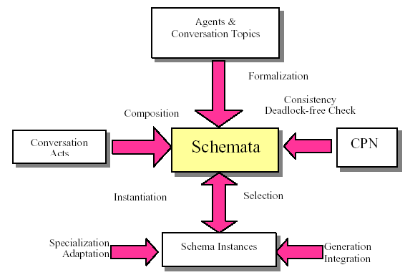
2
3
4

Conversation Topics

Definition 1:
A conversation topic (TP) can be defined as a 3-tuples

TP : (TP_ID, AGENTS, ARGUMENTS)
where
TP_ID=identity of a TP;
AGENTS=list of agents involved in the topic;
ARGUMENTS= lists of arguments in the topic.

Example 1:

In a manufacturing environment To achieve common agreement about the indexes of a production order (due date, price, location) a Logistics Agent (LOA), a Production Planning Agent (PPA), and a Factory Agent (FAA) conduct "several" conversations with different topics.

Representation:

TP : (TP_ID, AGENTS, ARGUMENTS)

TP1: A conversation interaction between LOA and PPA about a production target "to ship products <<Cust_order>> to a customer <<Cust>> who is at location <<Loc>> within the due date <<DD>> and price <<Price>>"

TP1: Prod_Tar LOA Cust_order
PPA Cust
Loc
DD
Price

Representation:

TP : (TP_ID, AGENTS, ARGUMENTS)

TP2: A conversation interaction between PPA and FAA about a manufacturing cost "to manufacture a factory order <<Factory_order>> within the due date <<DD>> and cost <<Cost>>"

TP2: Mfg_Cost PPA Factory_order
FAA DD
Cost

TP : (TP_ID, AGENTS, ARGUMENTS)
//Please remember these they will be referred

TP1: Prod_Tar LOA Cust_order
PPA Cust
Loc
DD
Price

TP2: Mfg_Cost PPA Factory_order
FAA DD
Cost

A conversation topic (TP) hence defines:

A unit of information exchanged by participating agents, without reference to the conversational implementation of the information or the control mechanisms of the information exchanged

  - Exchange of information at a high level of abstraction
(i.e. Do not describe leaf level information exchanges like requests, replies, acknowledgements)

  - Do not describe timing/sequence of interactions

Conversation schemas
A pattern of conversation interactions specifying Conversation Policies centered on one or more conversation topics that are extracted from application domain at domain analysis stage.

Definition 2:
A conversation schema consists of 4-tuples:
Conv-schema : (Agents, Acts, States, Arcs, TPs)
where
- Agents = {Agt1, Agt2, … , Agtm}
//Set of agents participating in the conversation;
- Acts = {Act1, Act2, … , Actn}
//Packets of conversation acts performed together by each agent;

Continued

- States = {Sta1, Sta2, … , Stal}
//Corresponding state changes of each agent;

- Arcs = (Acts X States) U (States X Acts)
//Relations between Acts and States.

- TPs = {Tp1, Tp2, … , Tpk}
//Set of conversation topics relevant for agents in the conversation.

- m, n, l, k > 0

A Conversation Schema is composed by identifying

  - Conversation acts
  - Internal state changes
  - External information exchange related to TP(s)
//one or more

Example 2:

After receiving a customer order, the LOA needs to find collaborators who can assist this order. LOA hence will request Local Area Coordinator (LAC) to obtain information about "how to collaborate". Then the LAC will request some Knowledge Agent (KA) to help find some suitable collaborators. Once a collaborator is found the replying actions will occur in the reverse order.

Conv-schema : (Agents, Acts, States, Arcs, TP(s))

CS1: LOA … who to collaborate with
LAC1
KA1

Representation:

Conv-schema : (Agents, Acts, States, Arcs, TP(s))

CS1: LOA … who to collaborate with
LAC1
KA1

Observe that
  - This schema might also be suitable for a Production Planning Agent (PPA) and a Factory Agent (FAA) in the following sense:

(Note: States and Acts will be discussed later)

Conv-schema : (Agents, Acts, States, Arcs, TP(s))

CS1: LOA ... who to collaborate with {TP35}
LAC1
KA1

CS1: PPA ... part information of product {TP23} LAC2
KA2

CS1: FAA ... feature information of product {TP57}
LAC3
KA3

Continued:

  - CS1, hence, can be called the "INFORMATION OBTAINING SCHEMA".

  - A "DUE DATE NEGOTIATION SCHEMA” can be constructed from TP1 and TP2 of Example 1.

TP : (TP_ID, AGENTS, ARGUMENTS)
//Refreshment slide//

TP1: Prod_Tar LOA Cust_order
PPA Cust
Loc
DD
Price

TP2: Mfg_Cost PPA Factory_order
FAA DD
Cost

Conv-schema : (Agents, Acts, States, Arcs, TP(s))

"INFORMATION OBTAINING SCHEMA"
CS1: LOA ... who to collaborate with {TP35}
LAC1, LAC2, LAC3 part information of product {TP23} KA1, KA2, KA3 feature information of product {TP57}

"DUE DATE NEGOTIATION SCHEMA" (Example 1) //Remember//
CS12: LOA ... production target {TP1}

PPA manufacturing cost {TP2}
FAA

Observe

Connections are not explicit in this type of representation, that is who speaks to who for which TP is not shown

  - The CS1 conversation schemas share the same Acts = {REQUEST, REPLY}

  - REQUEST and REPLY over here are called the "Atomic Schemas".

Summary so far:

  - A Conversation Schema basically links conversation topics to certain lower-level conversation acts which are called the Atomic Schemas.

Figure 2: Example for goal directed schema: Due-date Negotiation

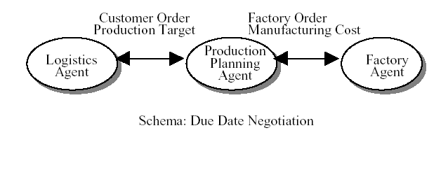
Schema Representation
  - Atomic Schemas Construction
  - Composite Schemas Construction

1) Atomic Schemas Construction. Lowest level interactions in a conversation are captured through Atomic Schemas.

Step1. Depict each "communication act" in a "schema" as a transition in CPN. Align transitions horizontally for each agent.

Step2. For each agent depict information exchanges between communication acts by arcs (connecting a set of places).

Step3. Add collective places for -between agent information exchanges-

Example 4:
Represent the atomic schema REQUEST (A,B) in terms of CPN

Conv-schema : (Agents, Acts, States, Arcs, TP(s))

Representation
REQUEST atomic schema
Agents : (A, B);
Acts : (request, continue, repair, req_ack, req_repair,
acknowledge, cancel);
States : (submitted, failed, succeeded);
Arcs : //relations between Acts and States;
TPs : (content).

Example: Logistic Agent (LOA) requests from Local Area Coordinator-1 (LOC1) the name of a possible collaborator.
Sample Conversation Policies from the Suite
"REQUEST" (Bradshaw, 1997)
Figure 3. CPN-represented atomic schema: REQUEST(A, B). (a) Drawing the transitions; (b) Adding places and arcs between transitions for each agent; (c) Adding collective state places that take place among the agents for information exchange. Arc inscriptions not shown.
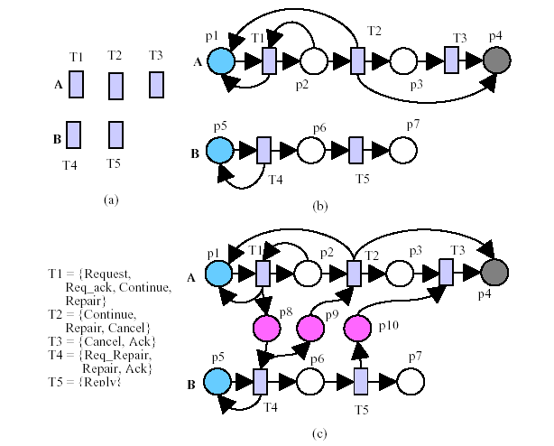

2) Composite Schema Construction
Composite schemas are constructed through the use of OO principles such as aggregation, classification, instantiation, inheritance from lower level schemas.

Example 5:
Create the "INFORMATION OBTAINING SCHEMA" (of example 2) by aggregating the following three atomic schema {REQUEST, REPLY and ACK}

//meaning: fold the three cases in Example 2 into one CPN.

REQUEST-atomic schemas
Agents : (A, B),
Acts : (request, continue, repair, req_ack, req_repair, acknowledge, cancel),
States : (submitted, failed, succeeded),
Arcs : //relations between Acts and States {Acts X States U States X Acts}
TPs : (content).

INFORMATION OBTAINING-composite schemas

Agents : (X, Y, Z), //LOA, LAC1, LAC2, LAC3, KA1, KA2, KA3
Acts : (<<REQUEST>>, REPLY, ACKNOWLEDGE), //all atomic schemas
States : (submitted, failed, succeeded, ...),
Arcs : //relations between Acts and States {Acts X States U States X Acts}
TPs : (TP35, TP23, TP57).

DUEDATE NEGOTIATION-composite schemas
Agents : (LOA, PPA, FFA),
Acts : (<<REQUEST>>, REPLY, ACKNOWLEDGE, INFORM),
States : (submitted, failed, succeeded, ...),
Arcs : //relations between Acts and States {Acts X States U States X Acts}
TPs : (TP1, TP2).

Figure 4. Example of CPN-represented “Info-obtaining” Schema

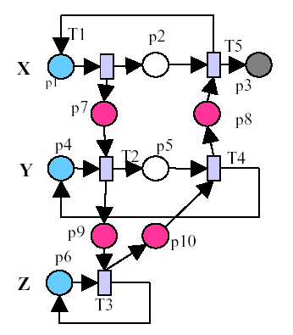
Color Sets in Transitions:
T1 = T2 =REQUEST(“intent”, “data_info.”)
T3 = T4 = REPLY(“intent”, “result_info.”)
T5 = ACK (result_info)

Color Sets in Places:
C(p1) = { <Cus_Order, LOA>, <Fac_Order, PPA>, <Mfg_Order, FAA}
C(p2) = C(p1)
C(p3) = { <LOA, PPA>, <PPA, Product Model>, <PPA (FAA), Feature
Model> }
C(p4) = {<LAC1>, <LAC2>, <LAC3>}
C(p5) = { <LAC1, Cus_Order>, <LAC2, Fac_Order>, <Mfg_Order,
FAA>}
C(p6) = {<KA1>, <KA2>, <KA3>}
C(p7) = C(p1)
C(p8) = {<PPA>, <Product Model>, <Feature Model>}
C(p9) = C(p5)

C(p10) = C(p8)

Figure 5a. Example of textual specification of CPN representation of “Info- obtaining” Schema
SCHEMA Info-obtaining;
INTERFACE:
INPORTS: p1, p4, p6
OUTPORTS: p3
ARCS: Pre(p1, T1) = <X, O, TP>, Pre(p4, T2) = <Y>,
Pre(p6, T3) = <Z>, Post(P3, T5) = <O, TP>
BODY:
PLACES: p2, p5, p7, p8, p9, p10;
TRANSITIONS: T1, T2: REQUEST; T3, T4: REPLY; T5: ACK;
ARCS:
Post(T1, p2) = <O>, Post(T1, p7) = <O, TP>, Pre(p7,T2) = <O>, Post(p5,T2) = <O>, Post(p9, T2) = <O, TP>, Pre(p9,T3) = <O, TP>, Post(p6, T3) = <Z>, Pre(p5, T4) = <O>, Pre(p10,T4) = <TP>, Post(p4, T4) = <Y>, Post(p8, T4) = <O, TP>, Pre(p2, T5) = <O>, Pre(p8, T5) = <O, TP>, Post(p1, T5) = <X>.
END SCHEMA

Figure 5b. Instances of the “Info-obtaining” Schema (continued)

INSTANCES Collaborator-finding;
INSTANCE OF info-obtaining;
INITIAL-MARKING: M(p1) = <Logistics Agent, Customer
order, Collaborator-finding>, M(p4) = (LAC1), M(p6) =<KA1>

END INSTANCE Collaborator-finding

INSTANCES Part-info-obtaining;
INSTANCE OF info-obtaining;
INITIAL-MARKING: M(p1) = <Production Planning Agent,
Factory order, Part-info-obtaining>, M(p4) = (LAC2), M(p6) = <KA2>
END INSTANCE Part-info-obtaining

INSTANCES Feature-info-obtaining;
INSTANCE OF info-obtaining;
INITIAL-MARKING: M(p1) = <Factory Agent,
Manufacturing Order, Feature-info-obtaining>, M(p4) =(LAC3), M(p6) = <KA3>
END INSTANCE Feature-info-obtaining

<< DEMO (s) >>
Figure 6. Dynamic execution of CPN-represented Schemas; “Due Date Negotiation” (including production target and manufacturing cost schemas)
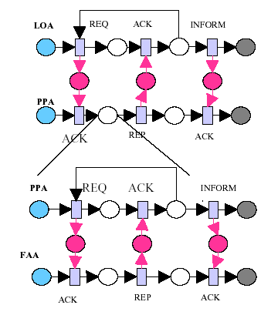

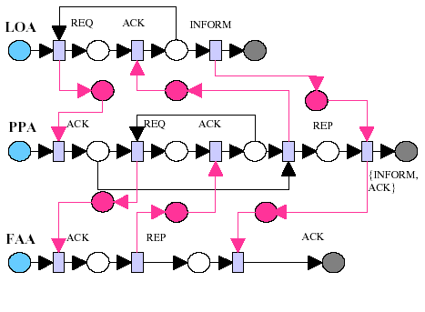

Outline:

Presentation of the paper
Communication challenges
Conversation Policy concept
Colored Petri Nets
Schema Based Conversation Modeling approach
⇒ Main idea of the paper
Strengths and weaknesses of the approach
Paper's explicit definition of MI reasoning
Paper's approach to six MI issues
How will the paper help my research
What related papers do I plan to read
Main idea of the paper

  - The ultimate result of a conversation is a change in the states of the participants (states: knowledge, goal, other attributes).

  - Paper proposes to come up with CPN-based descriptions of what a group of agents would do in certain situations (Conversation Schema classes).

  - Such classes are proposed to specify 1) Available conversation policies; 2) Their control mechanisms; 3) Local knowledgebases that maintain "state" of the conversation and agents.

  - In a CPN-represented conversation model, intentions and situations of agents involved in a conversation can really be represented by tokens with different types (colors).

Strengths and weaknesses of the approach
Strengths
Efficient, Reliable, Flexible ?

  - CPNs are mathematically formal and "cover "almost all graph theoretic representations (Generally every graphical representation can be represented in a Colored Petri Net form). CPNS allow valuable tools for logical, behavioral and performance evaluation of communication models.

  - The port and substitution transition concept in CPNs might especially prove useful, for easy integration of newer conversation policies to existing ones. New information can be added by replacing parts of a large net.

Weaknesses
Efficient, Reliable, Flexible?

  - Although for one/(a couple of) domains it is possible to come up with a set of schemas (with countable elements) to achieve coherency in communication (i.e. reliable, efficient, flexible communication), when larger domains are of concern, the number of schemas to be documented increase tremendously.

  - The structure of the communication model is fixed a priori. In certain ways, when a system uses schemas whether there is "reason"ing about its own behavior is questionnable. Adding information without reasoning, can bring traceability problems for large nets.

Paper’s implicit definition of Mixed Initiative reasoning

“Schema-based reasoning for cooperative problem solving”

  - Definition: Schema-based reasoning for cooperative problem solving is about the selection and adaptation of CPN-based conversation schemas by collaborating agents based on their beliefs, and desires to fulfill certain intentions under the constraints imposed by status of system resources.
Paper’s approach to six MI issues

  - The paper proposes a schema-based specification method for conversation policies in multi-agent systems.

  - The method's first loop aim is to enable seamless coordination and collaboration between agents.

  - This has a direct relationship with the communication issue; Protocols that facilitate exchange of knowledge and information between <<the human and>> the agent(s).

  - Communication issue, in return, effects the other 5 mixed initiative issues.

Figure 7. Mixed Initiative issues addressed within a CPN represented conversation model

Architecture Issue

Control Issue
Task
Issue
Communication Issue: The protocols that facilitate the exchange of knowledge and information between the human and the agent (s)

Awareness Issue
Evaluation Issue

Task Issue:

Division of responsibility between agent (s)

  - Conversation schemas define division of responsibility between agents. If a schema is chosen by an agent, the other agent's pattern of response is also limited to that schema.

  - When an agent receives a request to execute a new goal, a schema-matching process is triggered. The requests coming from various sources -i.e. the user, unanticipated events, other agents or from agent's own reasoning (sub-goals)- are placed on "todo" lists of agents (agenda).

Control Issue:

Shift of initiative and control between <<the human and>> the agent(s) including proactive behavior. Strategy that is used to shift initiative and control (random selection, single selection, continuous selection, oracle selection)

  - A central conversation control mechanism manages the change of initiative amongst agents (i.e. suspend current conversations while waiting for others to reach certain stages).

  - When an agent is initiating a conversation by using a communicative act, the receiving agent is "free" to select how he wishes to respond. In this case the control mechanism will do "active schema selection" by searching an intention schema table from an appropriate schema class.
Awareness Issue:

Maintenance of a shared awareness with respect to the current state of the agents involved agent's own capabilities, capabilities of other agents, capabilities of the world. Strategies for awareness maintenance (inferred state, explicit questioning, explicit information)

  - An actual conversation maintains the current state of the conversation, a set of conversation variables whose values are manipulated by conversation rules, and various historical information accumulated during conversation execution.

  - Each conversation schema class describes a conversation from the viewpoint of the agent group rather than the individual agent.

Architecture Issue:

Design principles and technologies for different types of roles and behaviors.

  - The CPN based modeling of conversation policies also influences the architectural aspects in the design of systems. The designers can implement the idea under various architectures for specific applications.

Evaluation Issue:
<<Human and automated>> agent(s) contribution to the system's performance

  - Schema based approaches for modeling conversational interactions using CPNs allow valuable tools for the verification of systems that use this idea as a basis.
  - Included in these are the algorithms that have been developed by the Petri Net community for the last three decades (i.e. completeness, deadlock freedom, S-invariant analysis etc.)
  - Logical, behavioral and performance evaluation of communication models are possible.

How will the paper help my research

  - The Culture-Performance Problem: Can culture be captured in interactions ?

  - The Interaction Schemas Idea: Do people from different cultures follow consistent discourse patterns while collaborating with others ?

  - From communicative interactions to organization architectures.

What I plan to do for the future

  - Continue my research revolving around conversation, discourse, speech act theory, dialogue theory.

  - Some Recent Papers:

  - R. Scott Cost, Ye Chen, Tim Finin, Yannis Labrou, Yun Peng (1999) “Modeling Agent Conversations with Colored Petri Nets”, Working Notes of the Workshop on Specifying and Implementing Conversation Policies

  - Flores, R.A. & Kremer, R.C. (2002) “A Model for Flexible Composition of Conversations: How a Simple Conversation got so Complicated”, in M.P. Huget, F. Dignum & J.L. Koning (Eds.), Proceedings of the 3rd Workshop on Agent Communication Languages and Conversation Policies.
Reference:

- Bradshaw, J. M., Dutfield, S., Benoit, P. & Woolley, J.D. (1997) KAoS: Toward an industrial-strength open agent architecture. In J.M. Bradshaw (Ed.) Software Agents.AAAI/MIT Press, pp.375-418.

- Lin, F., Norrie, D.H., Shen, W., and Kremer R. (1999) Schema-based Approach to Specifying Conversation Policies. Autonomous Agents '99 Workshop on Specifying and Implementing Coversation Policies, Seattle, WA. pp. 71-77.

- Jensen, K. (1992) Colored Petri Nets: Basic Concepts, Analysis Methods and Practical Use, vol. 1, Springer-Verlag, New York.
Reference:

- Levis, A. (2000) Discrete Event Systems Course Slides, System Architectures Laboratory, George Mason University.

- Levis, A. (2002) C4ISR Architecture Framework Implementation Course Slides, System Architectures Laboratory, George Mason University.

- Teccuci, G. (2004) Doctorial Tutorial Mixed-Initiative Intelligent Systems Course Slides, Learning Agents Center, George Mason University.

- Turner, E. H. and R.M. Turner (1991) A schema-base approach to cooperative problem solving with autonomous underwater vehicles. Proceedings of the IEEE Oceanic Engineering Society, Honolulu, Hawai

More on:
http://viking.gmu.edu/bios/aolmez/803.htm

