Agent Shell for the Development of Tutoring Systems
for Expert Problem Solving Knowledge
Vu Le^{1,2}, Gheorghe Tecuci¹, Mihai Boicu¹

¹ MSN 6B3, Learning Agents Center, Volgenau School of Information Technology and Engineering, George Mason University, 4400 University Dr., Fairfax, VA 22030, USA
email: vu.le@baesystems.com, tecuci@gmu.edu, mboicu@gmu.edu, http://lac.gmu.edu
² Advanced Information Technology, BAE Systems, 3811 N. Fairfax, Arlington, VA 22203
Abstract. This paper introduces the concept of learning and tutoring agent shell as a general and powerful tool for rapid development of a new type of intelligent assistants that can learn complex problem solving expertise directly from human experts, can support human experts in problem solving and decision making, and can teach their problem solving expertise to non-experts. This shell synergistically integrates general problem solving, learning and tutoring engines and has been used to build a complex cognitive assistant for intelligence analysts. This assistant has been successfully used and evaluated in courses at US Army War College and George Mason University. The goal of this paper is to provide an intuitive overview of the tutoring-related capabilities of this shell which rely heavily on its problem solving and learning capabilities. They include the capability to rapidly acquire the basic abstract problem solving strategies of the application domain, directly from a subject matter expert. They allow an instructional designer to rapidly design lessons for teaching these abstract problem solving strategies, without the need of defining examples because they are automatically generated by the system from the domain knowledge base. They also allow rapid learning of test questions to assess students’ problem solving knowledge. The proposed type of cognitive assistant, capable of learning, problem solving and tutoring, as well as the learning and tutoring agent shell used to build it, represent a very promising and expected evolution for the knowledge-based agents for “ill-defined” domains.
Keywords: ITS-building tool, ITS authoring, agent-based tutoring systems, knowledge acquisition, machine learning in ITS, intelligent agents, ill-defined domains, intelligence analysis, teaching problem solving expertise, lesson design and generation, test learning and generation.

1 Introduction
Building intelligent tutoring systems is notoriously hard. It requires teams that typically include software developers, knowledge engineers, subject matter experts, and instructional designers, which are estimated to need between 300 and 1000 hours to produce an hour of instructional material [1, 2]. Although impressive successes have been demonstrated by many advanced ITS authoring systems, such as CAT [3] or RIDES [4], these and the vast majority of the developed systems are for “well-defined” domains (which allow for a clear distinction between good and bad answers or solutions), in spite of the fact that many domains, such as design, law, medical diagnosis, history, intelligence analysis, and military planning, are “ill-defined” [5].
This paper presents a new approach for building tutoring systems that can teach new professionals how experts solve problems in a complex “ill-defined” domain [5]. This approach leads to the development of a new type of cognitive assistant that in addition to tutoring has powerful capabilities for learning and problem solving. It can:
- rapidly learn, directly from a subject matter expert, the problem solving expertise which currently takes years to establish, is lost when experts separate from service, and is costly to replace;
- tutor new professionals the problem solving expertise learned from the subject matter expert;
- assist a professional to solve complex problems, through mixed-initiative reasoning, allowing a synergistic integration of the professional’s experience and creativity with the agent’s knowledge and speed, and facilitating collaboration with complementary experts and their agents.
The developed methods for building such cognitive assistants have been implemented into a new type of tool, called learning and tutoring agent shell. This shell can be taught by a subject matter expert, and can then teach students in ways that are similar to how it was taught. The shell has been used to build a cognitive assistant for intelligence analysts that has been successfully used in courses at the US Army War College and George Mason University [6]. Because of the number and complexity of the methods integrated into the shell, in this paper we will present only those related to its tutoring capabilities, giving only minimal information about the others, which are described in [7], [8]. Moreover, even the tutoring capabilities will be presented at a very general, conceptual level. Our goal is to provide an as intuitive as possible view on this new approach to building systems for tutoring complex problem solving expertise in “ill-defined domains”. A detailed description of this approach is presented in [9].
The next section introduces the concept of learning and tutoring agent shell and the associated methodology for building cognitive assistants. Section 3 introduces the intelligence analysis domain, as well as the problem solving approach implemented in the shell, which is pedagogically tuned. Section 4 presents our approach to the abstraction of the reasoning trees which facilitates the identification and tutoring of the main problem solving strategies of a domain. Section 5 presents the lesson design and generation process and Section 6 presents the learning and generation of test questions. This is followed by a presentation of some experimental results, a summary of the main contributions, current limitations and future research directions.

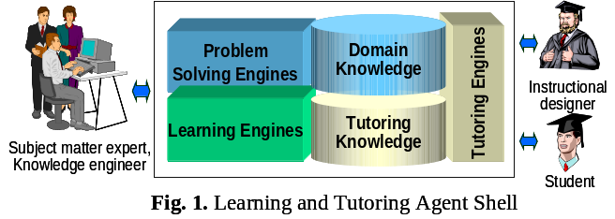
2 Learning and Tutoring Agent Shell (LTAS)
Fig. 1 shows the overall architecture of an LTAS. This is an extension of the concept of learning agent shell [7] which is itself an extension of the concept of expert system shell [10].
The problem solving engines of our LTAS employ a general, divide-and-conquer, approach to problem solving, called problem-reduction/solution-synthesis, which is applicable in a wide range of domains [7], [11]. In this approach, which will be illustrated in the next section, a complex problem is successively reduced to simpler and simpler problems, the solutions of the simplest problems are found, and then these solutions are successively composed, from bottom up, until the solution of the initial problem is obtained. To exhibit this type of problem solving behavior, the domain knowledge base should contain an object ontology (which describes the objects from an application domain) and a set of problem reduction or solution synthesis rules (expressed with the objects from the ontology). A problem reduction rule expresses how and under what conditions a generic problem can be reduced to simpler generic problems. A solution synthesis rule expresses how and under what conditions the solutions of generic subproblems can be combined into the solution of a generic problem. The conditions are complex first-order logical expressions [6], [8].
The learning engines employ general mixed-initiative, multistrategy methods that allow a subject matter expert to teach the agent in a way that is similar to how the expert would teach a person [7], [8]. For instance, the expert will show the agent how to solve a specific problem, will help it to understand the corresponding reasoning process, and will supervise and correct its behavior when the agent attempts to solve similar problems. As a result, the agent will learn general reduction and synthesis rules and will extend its ontology. Moreover, the acquired knowledge will be pedagogically tuned [12] because the agent will solve new problems and will explain its reasoning process similarly to how the expert did it.
The tutoring engines, which will be described in more detail in this paper, allow the acquisition of pedagogical knowledge, the design and generation of lessons, and the learning and generation of test questions.
To build a cognitive assistant, the subject matter expert first teaches the agent shell (LTAS) and develops its domain knowledge base (consisting of the object ontology, the problem reduction rules and the solution synthesis rules). Then the expert teaches the agent the elementary abstract reasoning strategies of the application domain, as discussed in Section 4. After that, the instructional designer designs the lessons based on the abstract reasoning strategies. The instructional designer also teaches the agent how to generate test questions, as discussed in Section 5.
We will provide an intuitive overview of the tutoring-related capabilities based on the Disciple-LTA analyst’s cognitive assistant that was developed with the learning and tutoring shell for the “ill-structured” domain of intelligence analysis [6], [13].

3 Disciple-LTA: Analyst’s Cognitive Assistant
Disciple-LTA solves intelligence analysis problems, such as, “Assess whether Iran is pursuing nuclear power for peaceful purposes” or “Assess whether Al Qaeda has nuclear weapons, based on partial, uncertain, and even false information from open-source pieces of evidence (such as, newspaper articles, web sites, news agency reports, books, etc.).
As indicated in the previous section, the way the agent solves an intelligence analysis problem is similar to how the expert solved such problems when he or she taught the agent. It is as if the agent is “thinking aloud”, asking itself questions that guide the problem reduction process, as illustrated in Fig. 2 and copied below:
I need to: Assess whether Al Qaeda has nuclear weapons.
Q: What factors should I consider to determine whether Al Qaeda has nuclear weapons?
A: Characteristics associated with possession of nuclear weapons and current evidence that it has nuclear weapons.
Therefore I need to solve two subproblems:
Assess the possibility that Al Qaeda might have nuclear weapons based on the
characteristics associated with the possession of nuclear weapons.
Assess the current evidence that Al Qaeda has nuclear weapons.
Q: What are the characteristics associated with possession of nuclear weapons?
A: Reasons, desire, and ability to obtain nuclear weapons.
Therefore I need to solve three sub-problems:
Assess whether Al Qaeda has reasons to obtain nuclear weapons.
Assess whether Al Qaeda has desire to obtain nuclear weapons.
Assess whether Al Qaeda has the ability to obtain nuclear weapons.
In this way, the initial problem is successively reduced to simpler and simpler problems which are shown with a blue background in Fig. 2. Then the solutions of the
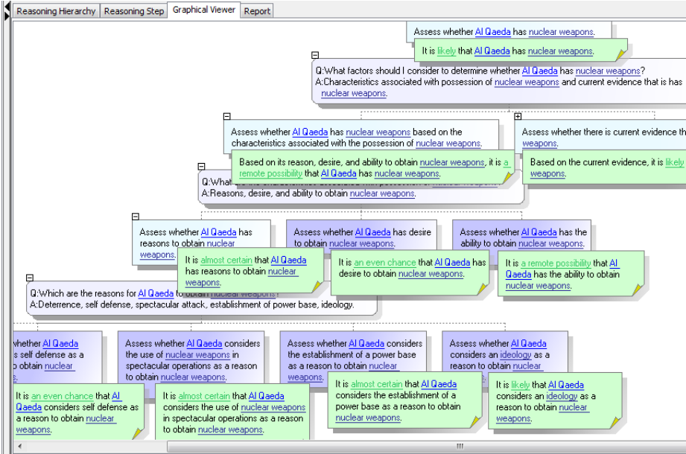
Fig. 2. Hypothesis analysis through problem reduction and solution synthesis.
simplest problems are found, and these solutions (which are shown with a green background) are successively composed, from bottom up, until the solution of the initial problem is obtained (i.e. “It is likely that Al Qaeda has nuclear weapons.”).
The intelligence analysts who have used our system, evaluated this type of reasoning as being very appropriate for teaching new analysts because it is very explicit and natural. However, the reasoning trees generated by the agent for real-world problems are very large. For example, Fig. 2 shows only the top 23 nodes of a tree that has 1,758 nodes. The question is how to systematically teach new analysts based on such complex trees. Our solution is described in the next sections.

4 Abstraction of Reasoning Trees
Although the reasoning trees generated by the agent are very large, its parts are repeated applications of a few abstract reasoning strategies. This is illustrated in Fig. 3 where the blue-bordered subtrees from the left-hand side are concrete applications of the abstract reduction strategy shown with a red-border in the right-hand side. Indeed, each of the blue subtrees represents the following abstract strategy:
In order to assess to what extent a certain piece of evidence (e.g. EVD-Reuters-01-01c, a fragment from a Reuters News Agency report) favors a certain hypothesis (e.g. “Al Qaeda desires to obtain nuclear weapons.”), one has to solve two subproblems: 1) Assess to what extent that piece of evidence favors that hypothesis, assuming that the piece of evidence is believable, and 2) Assess the believability of that piece of evidence.
There are other abstract strategies for analyzing the believability of direct testimonial evidence, or the believability of testimonial evidence obtained at second hand, or the credibility of tangible evidence, or the competence and credibility of primary or intermediary sources of information, etc. [13].
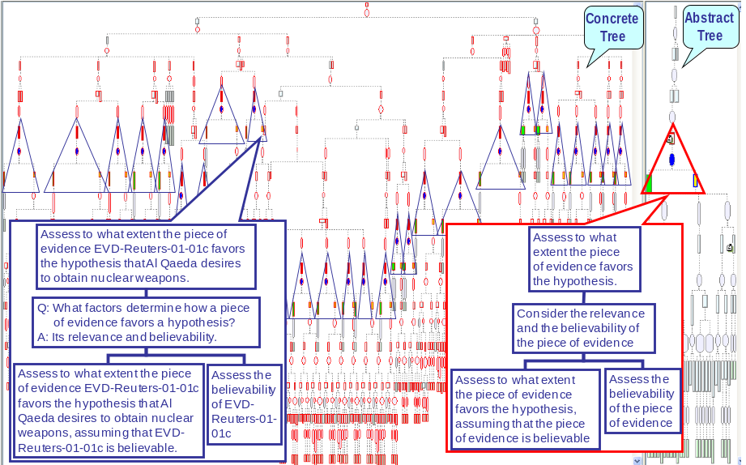

Fig. 3. Concrete and abstract reasoning trees.
Our LTAS includes an abstraction learning module that allows the agent to learn abstraction rules from a subject matter expert. In essence, the expert abstracts a concrete reasoning subtree CT (such as the one from the bottom left of Fig. 3) into an abstract subtree AT (i.e. the one from the bottom right of Fig. 3). From this example of abstraction (CT → AT) the system learns a general abstraction rule AR. AR incorporates the complex reasoning rule(s) R that generated the concrete subtree CT. The abstraction rule AR allows the system to automatically identify concrete applications CT_{i} of the abstract reasoning strategy AT in a concrete reasoning tree. In all, there are only 22 abstract reduction strategies and 22 abstract synthesis strategies that are repeatedly applied to generate the large reasoning tree for solving the problem Assess whether Al Qaeda has nuclear weapons. As a consequence there are only 217 abstract nodes in the abstract reasoning tree that correspond to 1758 nodes in the concrete tree.
In conclusion, the abstraction process helps to identify the problem solving strategies based on which complex reasoning trees are generated. Therefore, an approach to teach new professionals how to solve problems is to teach them the abstract reasoning strategies of their domain, illustrating them with concrete examples, as will be discussed in the next section.

4 Lesson Design and Generation
Each basic abstract strategy, or a small set of related ones, is the foundation of a lesson designed with our LTAS. For example, Fig. 4 shows a fragment of the lesson that teaches an analyst how to assess the support provided by a piece of evidence to a hypothesis. The top part of Fig. 4 teaches the analyst how to solve this problem at the abstract level and the bottom part illustrates this abstract reasoning with examples generated from the domain knowledge base. The abstract reasoning teaches four basic abstract strategies but only the top strategy and one of the three bottom strategies are visible in Fig. 3. Each of the three bottom strategies shows an alternative way of assessing the extent to which the information provided by a piece of evidence is believable, depending on the type of evidence (i.e. direct testimonial evidence, testimonial evidence obtained at second hand, or testimonial evidence about tangible evidence). The tutor fades out the two strategies which are not illustrated by the example from the bottom part of Fig. 4 (see the right hand side of Fig. 4). A student can request additional examples that illustrate the other strategies, or could directly select them from a list. He or she could also click on the blue hyperlinks to receive brief or detailed definitions or even entire presentations on important concepts such as believability or objectivity [13]. Some lessons may display these descriptions automatically, as part of the lesson’s flow, which may also use spoken text.
Fig. 4 illustrates only the first part of the lesson which teaches the reduction strategies for assessing the support provided by a piece of evidence to a hypothesis. The second part of the lesson teaches the corresponding synthesis strategies.
LTAS allows an instructional designer to create lessons and organize them into a curriculum, by using a set of drag and drop operations to specify the basic abstract strategies to be included into the lesson, the order in which they will be taught, as well as additional explanations and definitions. The result is a lesson script that is executed by the lesson generation module to create a lesson like that illustrated in Fig. 4.
Notice that the instructional designer does not need to specify the lesson’s examples because they are automatically generated from the domain knowledge base. This significantly speeds up the lesson design process. Moreover, this provides a high level of generality to the developed curriculum and offers a solution to the customized tutoring of students who have different domain knowledge and interests. Indeed, a student may select a specific domain knowledge base of interest (e.g. for drug trafficking or crime investigation, instead of nuclear proliferation), and the tutoring system will generate examples from it, without any change in the lessons.
There are additional ways in which the tutoring is automatically customized. For instance, the lessons will only teach the reasoning strategies that can be illustrated in the selected domain knowledge base, and the test questions for assessing a student will also be generated from that knowledge base, as discussed in the next section.

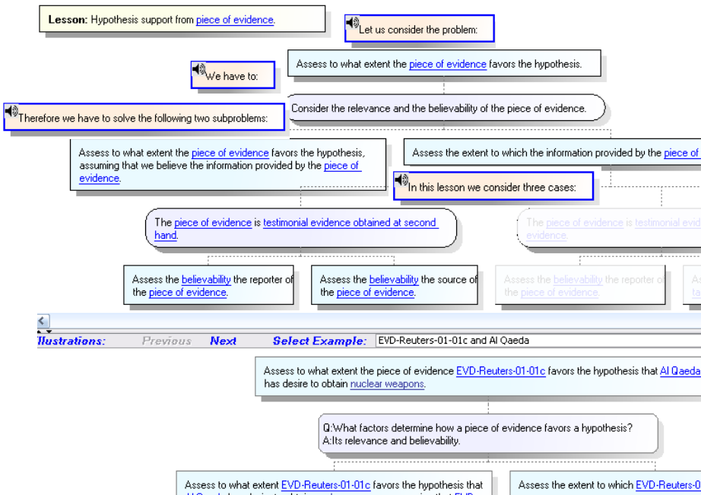
Fig. 4. The top-left part of a lesson interface.

5 Learning and Generation of Test Questions
LTAS includes a module that allows the instructional designer to rapidly teach the agent how to automatically generate several types of test questions to assess students’ problem solving knowledge. An example of generated test question is shown in Fig. 5 where a red-bordered problem is reduced to two red-bordered subproblems (see bottom of Fig. 5), in the context of a larger reasoning tree. The student is asked whether this reasoning is complete (i.e. includes all the necessary subproblems of the reduced problem), or incomplete (misses some subproblems but the present ones are correct), or incorrect (includes incorrect subproblems), by clicking on the corresponding answer in the upper right-hand of Fig. 5. The student will receive an appropriate feedback confirming the answer or explaining the mistake. He or she may also request a hint and, in the case of self-testing mode (as opposed to assessment), may review the corresponding lesson by clicking on the “Go To Lesson” button.
The test question in Fig. 5 is of type omission, because one of the subproblems was omitted, and tests the student at the knowledge level [14]. A test of type modification (where no subproblems are omitted, but some of them have been modified) tests the student at the comprehension level. Finally, a test of type construction (where the student selects the correct subproblems of a given problem, from a larger list of potential subproblems) tests the student at the analysis level.
To teach the agent how to generate a class of test questions, the instructional designer selects a reduction step from a reasoning tree generated by the agent. This step, represented by a problem and its subproblems, is an example E of a previously learned problem reduction rule R from the domain knowledge base. Then the instructional designer changes the reduction step E, either by deleting some subproblems, or by modifying them, or by adding additional deliberately incorrect subproblems, to create an omission, modification, or construction test example, respectively. The instructional designer also provides a specific hint for the test example, as well as specific feedback for each of the possible student answers (i.e. correct, incomplete, and incorrect). The result is a specific test example TE which is an extension and modification of the reduction example E. By performing corresponding extensions and modifications of the general rule R (which generated E), the agent learns the general test question rule TR. TR can generate a class of test questions similar to TE, based on the current domain knowledge base.
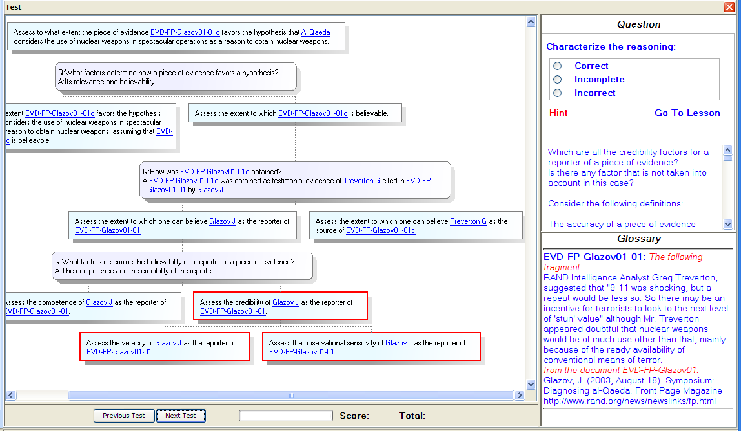
The lesson scripts and the test generation rules are stored in the pedagogical knowledge base which also represents the student model. The model stores specific information about a particular student, such as the lessons taken and his or her

Fig. 5. Sample test question.
performance on the test questions. It informs the test generation module to only generate tests related to the lessons taken by the student, as well as additional tests similar with those failed by the student.

5 Experimentation
The Disciple-LTA cognitive assistant developed with the LTAS tool has been used and evaluated in several courses at the US Army War College and at George Mason University [9]. The Army War College students were high ranking military officers that were either experienced intelligence analysts or users of intelligence. In contrast, George Mason students were computer science graduate students with no significant intelligence analysis experience. In both cases the students followed the lessons defined in the system and then were assessed based on the test questions generated by the system. As expected, the system was perceived as more useful by the novice analysts. However, even the expert analysts from the Army War College considered that the system was useful in teaching them a rigorous systematic approach for the “ill-defined” domain of intelligence analysis. Both before and after taking the lessons, the students from George Mason University (i.e. the novice analysts) were asked to subjectively assess their knowledge of several topics taught, on a 6-point scale, from none to very high. The results showed that the students considered that their post-lessons knowledge of the application domain was much better than their pre-lessons knowledge. Moreover, their self-assessed post-lesson knowledge was confirmed by the good results obtained by the students at the tests questions generated by the agent.

6 Summary of Contributions, Limitations and Future Research
While significant results have been demonstrated by many ITS authoring systems (e.g. [3], [4], which have advanced machine learning and authoring capabilities), most of the work has been done in the context of “well-defined” domains, such as physics, chemistry or mathematics [1], [3-5].
In this paper we have presented an overview of our research on a new approach to the development of systems for tutoring expert problem solving knowledge in an “ill-defined” domain [5]. This approach is based on methods from the areas of expert systems, machine learning, and intelligent tutoring systems, which we have developed over many years, and have integrated into a new type of tool, called learning and tutoring agent shell or LTAS (see Fig. 1). This tool allows rapid development of a new type of cognitive assistant that can be taught by subject matter experts and can then teach new professionals, as well as support them in problem solving and decision-making. LTAS is applicable to a wide range of ill-defined domains, due to its use of the general problem-reduction/solution-synthesis approach to problem solving. It also allows rapid acquisition of an expert’s problem solving knowledge, based on powerful mixed-initiative, multistrategy learning methods that integrate learning from examples, learning from explanations, learning by analogy, and learning by abstraction. These capabilities have been used to develop problem solving and learning agents for complex problems, such as military course of action critiquing [15], military center of gravity analysis [8], and emergency response planning [16].
The tutoring capabilities of LTAS, introduced in the previous sections, have been only recently developed and rely heavily on its problem solving and learning capabilities. They include the capability to rapidly acquire the basic abstract problem solving strategies of the application domain, directly from a subject matter expert. They allow an instructional designer to rapidly design lessons for teaching the abstract problem solving strategies, without the need of defining examples because they are automatically generated by the system from the domain knowledge base. They also allow rapid learning of test questions. These capabilities confer a high degree of generality to the tutoring system that can be applied to several related application domains (such as, nuclear proliferation, drug trafficking, crime investigation, or law) with no change to the lessons.
REDEEM [2] is an authoring environment that allows classroom teachers to easily create a simple ITS by importing a computer-based training course as the domain content and by selecting among a wide variety of strategies for teaching it. While also focusing on instructional delivery (rather than coached problem solving) the teacher customizations allowed by the current version of Disciple-LTA are not as varied and as easy to perform, but they involve a much more complex ITS. Also, Disciple-LTA allows the students themselves to customize the lessons, by selecting not only the lesson’s examples that illustrate the taught problem solving strategies, but even the domain knowledge base, to better fit their interests and knowledge.
Using LTAS we have developed a complex cognitive assistant for intelligence analysts which has been successfully used in several courses with both expert analysts and novice analysts.
Tutoring problem solving expertise is not only important for teaching new professionals, but also for teaching any person who desires to use a complex problem solving and decision-support assistant. Indeed, such an assistant will generate complex reasoning trees, as shown in Fig. 2 and Fig. 3, which the user needs to understand, browse, modify and extend. This makes tutoring a necessary capability of any complex assistant. On the other hand, as demonstrated by our research, existing problem solving and learning capabilities greatly facilitate the development of the tutoring capabilities. We therefore consider that the proposed type of cognitive assistant, capable of learning, problem solving and tutoring, as well as the learning and tutoring agent shell used to build it, represent a very promising and expected evolution for the knowledge-based agents.
The developed tutoring-related methods and their implementation in the current version of LTAS have several limitations which point to future research directions. For example, the lesson design module requires that a lesson should first introduce an abstract strategy and then illustrate it with examples. It is easy to extend this module to allow an instructional designer to define other types of lesson organizations, such as introducing first examples and then their abstraction, as in REDEEM [2].
The types of test questions currently learned and generated by the system are not very complex and diverse, each test question being based on a single problem solving rule from the domain knowledge base. It would not be very difficult to learn more complex test questions that are based on several related reasoning rules. It is also necessary to imagine new and more challenging types of test questions.
The current student model is quite limited and more research is needed both to develop a more complex model, and to more effectively use it in tutoring. In addition, more work is needed to significantly improve the interaction with the student.

References
1. Murray, T.: An overview of intelligent tutoring system authoring tools: Updated analysis of In: Murray, T., Blessing, S., Ainsworth, S.E. (eds.) Tools for Advanced Technology Learning Environments, pp. 491—544. Amsterdam: Kluwer (2003)
2. Ainsworth, S.E., Fleming, P.F.: Teachers as instructional designers: Does involving a classroom teacher in the design of computer-based learning environments improve their effectiveness? In: Gerjets, P., Kirschner, P. A., Elen, J., Joiner, R. (eds.) Instructional design for effective and enjoyable computer-supported learning. Proceedings of the first joint meeting of the EARLI SIGs Instructional Design and Learning and Instruction with Computers, pp 283--291, (2004)
3. Aleven, V., McLaren, B. M., Sewall, J., Koedinger, K.: The Cognitive Tutor Authoring Tools (CTAT): Preliminary evaluation of efficiency gains. In: Ikeda, M., Ashley, K.D., T. Chan, W. (eds.) Proceedings of the 8th International Conference on Intelligent Tutoring Systems (ITS 2006), pp. 61--70. Berlin: Springer Verlag (2006)
4. Munro, A., Johnson, M.C., Pizzini, Q.A., Surmon, D.S., Towne, D.M., Wogulis, J.L.: Authoring Simulation-Centered Tutors with RIDES. International Journal of Artificial Intelligence in Education, 8, 284-316 (1997)
5. Lynch, C., Ashley, K., Aleven, V., Pinkwart, N.: Defining Ill-Defined Domains; A literature survey. In: Aleven, V., Ashley, K., Lynch, C., Pinkwart, N. (eds.) Proceedings of the Workshop on Intelligent Tutoring Systems for Ill-Defined Domains at the 8th Int. Conference on Intelligent Tutoring Systems. pp.1--10. Jhongli (Taiwan) (2006)
6. Tecuci, G., Boicu, M., Marcu, D., Boicu, C., Barbulescu, M., Ayers, C., Cammons, C.: Cognitive Assistants for Analysts, Journal of Intelligence Community Research and Development (2007)
7. Tecuci, G.: Building Intelligent Agents: An Apprenticeship Multistrategy Learning Theory, Methodology, Tool and Case Studies. London, England: Academic Press (1998)
8. Tecuci, G., Boicu, M., Boicu, C., Marcu, D., Stanescu, B., Barbulescu, M.: The Disciple-RKF Learning and Reasoning Agent, Computational Intelligence, 21, 462--479 (2005)
9. Le, V.: Abstraction of Reasoning for Problem Solving and Tutoring Assistants. Ph.D. Dissertation in Information Technology. Learning Agents Center, Volgenau School of IT&E, George Mason University, Spring 2008
10. Clancey, W.J.: NEOMYCIN: Reconfiguring a rule-based system with application to teaching. In: Clancey, W.J., Shortliffe, E.H. (eds.) Readings in Medical Artificial Intelligence, pp.361-381. Reading, MA: Addison-Wesley (1984)
11. Nilsson, N.J.: Problem Solving Methods in Artificial Intelligence, McGraw-Hill (1971)
12. Clancey, W.J.: Knowledge-Based Tutoring: The GUIDON Program. MIT Press (1987)
13. Schum, D.A.: The Evidential Foundations of Probabilistic Reasoning, Northwestern University Press (2001)
14. Bloom, B.S.: Taxonomy of Educational Objectives, Handbook I: The Cognitive Domain. David McKay Co Inc, New York (1956)
15. Tecuci, G., Boicu, M., Bowman, M., Marcu, D., Burke, M.: An Innovative Application from the DARPA Knowledge Bases Programs: Rapid Development of a High Performance Knowledge Base for Course of Action Critiquing, AI Magazine, 22:2, 43--61, (2001)
16. Tecuci, G., Boicu, M., Marcu, D., Barbulescu, M., Boicu, C., Le, V., Hajduk, T.: Teaching Virtual Experts for Multi-Domain Collaborative Planning, J. of Software, 3, 38--59 (2008)

This material is based on research partially sponsored by the Air Force Office of Scientific Research (FA9550-07-1-0268) and the Air Force Research Laboratory (FA8750-04-1-0257). The US Government is authorized to reproduce and distribute reprints for Governmental purposes notwithstanding any copyright notation thereon. The views and conclusions contained herein are those of the authors and should not be interpreted as necessarily representing the official polices or endorsements, either expressed or implied, of the Air Force Office of Scientific Research, the Air Force Research Laboratory or the U.S. Government.

