Evaluating Data
Gheorghe Tecuci
Learning Agent Center and Computer Science Department, George Mason University
tecuci@gmu.edu, http://lac.gmu.edu
1. Introduction
This exercise was adapted from:
Jonathan Osbome, Sibel Erduran, Shirley Simon, Ideas, Evidence & Argument in Science (IDEAS), King's College London, 2004, pp. 63-66, https://www.stem.org.uk/elibrary/collection/3308 https://www.stem.org.uk/resources/elibrary/resource/28125/ideas-resources
The students are presented with the following results from an experiment about the relationship between people's pulse rate and the number of breaths they take, reproduced from (Osbome, Erduran, and Simon, 2004, p. 65).
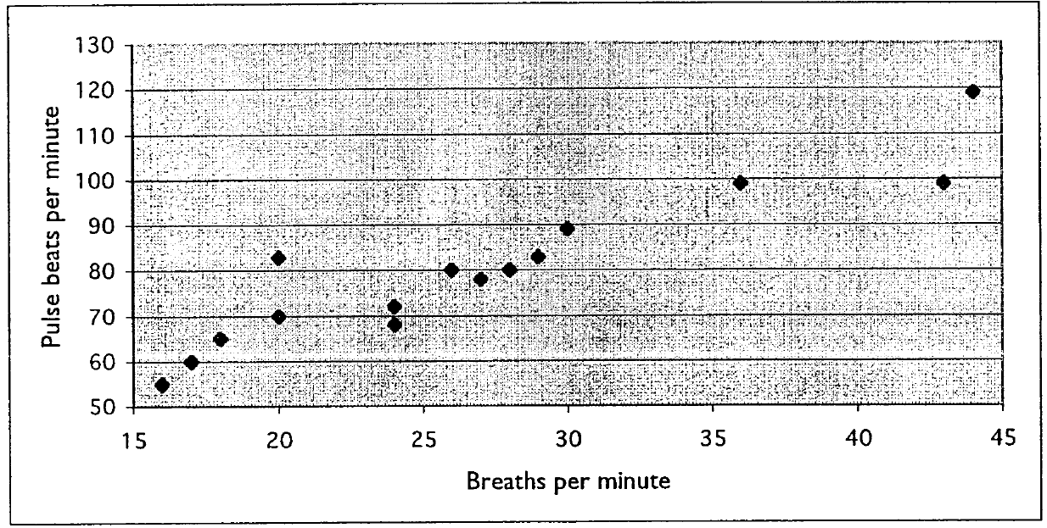
Their task is to develop argumentations that evaluate four different conclusions drawn from this data. Section 2 presents the inquiry and Section 3 presents the corresponding argumentation developed with the sInvestigator system. sInvestigator may be downloaded from http://lac.gmu.edu/sInvestigator/ The knowledge base containing the argumentation may be downloaded from http://lac.gmu.edu/sInvestigator/CaseStudies.html

2. Inquiry

What statement best characterizes the data, as a whole?
One pupil had the most breaths and she also had the highest pulse rate.
AII the people with a high breath rate had a high pulse rate.
The higher your breathing rate, the greater the pulse rate.
On the whole, those people with a higher breath rate had a higher pulse rate.

3. Analysis

